Basic sensors

LOTI.05.010 Robotics

Spring semester 2015/16

Practice session 5
In this lab you will learn how to use the simplest sensors. Until now you have only sent signals to devices. Now you will learn how to read data from basic sensors.

You will have to show each completed task to the instructors if not stated otherwise.

You will be connecting wires to Raspberry Pi GPIO. Shut down the Pi and disconnect the power before connecting the wires.

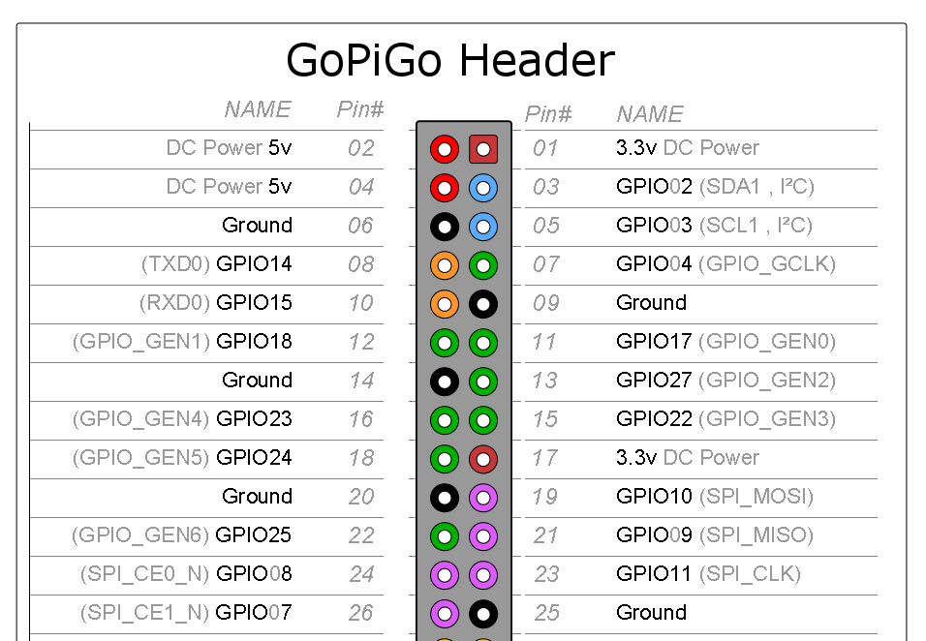

Really!! Shut down the Pi and disconnect the power before connecting the wires

PIR sensor
PIR (Passive InfraRed) sensors measure emitted infrared light in their field of view. They can be used to detect moving warm objects, such as humans. The sensors you use have digital outputs.
Connect the PIR sensor to your Raspberry Pi. The OUT pin on the PIR sensor should be connected to a GPIO pin of your choice (but NOT GPIO02 or GPIO03). +5V and GND pins should be connected respectively.

To read digital signals from the Raspberry Pi GPIO, you can use the RPi.GPIO module for python.

import RPi.GPIO as GPIO

# GPIO configuration here

# configure pin 'channel' as input and read value into var 'Digital_in'
GPIO.setup(channel, GPIO.IN)
Digital_in = GPIO.input(channel)
# this returns a True/False (or 1/0, GPIO.HIGH/GPIO.LOW, 3.3V/0V) value

Do not forget to end your code with
GPIO.cleanup()
If you are using RPi.GPIO.

Endless loop with one second sleep:
while True:
#your code here
time.sleep(1)
You can use Ctrl+C to terminate a program which has a endless loop.

Loop that runs 10 times, sleeps two seconds between each run:
for i in range(10):
#your code here
time.sleep(2)

With the PIR sensors we have, you can configure 3 things: sensitivity, output signal pulse duration, and retriggering mode. Get familiar with the PIR sensor configuration here:
https://learn.adafruit.com/pir-passive-infrared-proximity-motion-sensor/

Task 1
Create a surveillance robot that blinks the lights on the front of the GoPiGo for 5 seconds whenever the sensor detects humans.

Analog light sensor
Datasheet:
https://www.adafruit.com/images/product-files/2748/2748%20datasheet.pdf

Raspberry Pi does not have a ADC (analog-digital converter), that means you can only read digital signals, where there is two possible states: high or low. For Pi if the input voltage is below 0.8 V it is considered low, and if it is more than 1.2 V it is considered high. If it is in between those two voltages, the reading is undefined, that means you may get either high or low with no assurance.

To read analog signal you will need external ADC. Luckily GoPiGo board has a connector for ADC you can use.

This light sensor acts as a voltage divider. It has three pins, if you apply 5 V to two of them, you will get a reading of 0 - 5 V from the third pin. The voltage depends on the amount of light the sensor receives.

Shut down the Pi and disconnect the power before connecting the wires.
Connect the sensor to GoPiGo analog input marked as A1. Here is the pinout of the plug:
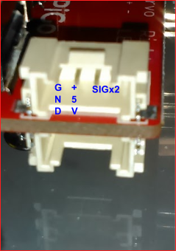
SIGx2 means that the pins are connected together on the board and it does not matter which one do you use. Because the wires we use are not meant for the connector, you may need to hold them in place to get a good connection.

Following code will read the sensor value and print it to console:
from gopigo import *
reading = analogRead(1)
print 'Sensor value:', reading

To check values:
if sensor >= 0 and sensor < 10:
print '0 <= reading < 10'
elif sensor >= 10 and sensor < 20:
print '10 <= reading < 20'
else:
print 'Reading is less that 0 or more than 20'

Task 2
Try to calibrate the sensor to following light levels:
- No light
- Classroom lights
- Bright light directly to light sensor
Print in the console which light source is detected (alongside the read value)
Do it in a loop and update value for every 0.5 seconds

If you are familiar with averaging, do it over 5-10 values and see if your output is more stable.

Ultrasonic distance sensor
Datasheet: http://www.micropik.com/PDF/HCSR04.pdf

When you apply a short pulse on the trigger pin, the sensor will send out a ultrasonic signal and measures the time how long the signal travels from the emitter to the receiver. After that the echo pin will be high for that amount of time. To get the distance you will have to measure for how long is the echo pin high.

First connect the sensor to GoPiGo header. VCC goes to 5V, GND to Ground, Trig and Echo to GPIO pins that are not GPIO02 or GPIO03 (those are used by GoPiGo I2C).

First you will have to put Trig high for certain amount of time (find the number in the datasheet):
GPIO.output(17, GPIO.HIGH)
time.sleep(enter_correct_time)
GPIO.output(17, GPIO.LOW)

Then you will have to measure the time for how long is the Echo pin high:
#Register start
while GPIO.input(27) == 0:
start_time = time.time()
#Wait until pin is low again
while GPIO.input(27) == 1:
end_time = time.time()
#To get the span, subtract end from start
time_passed = end_time - start_time

Now you will know how long it took for the sound wave to travel from the sensor to the obstacle and back. Calculate the distance, you can find the formula in the datasheet.
Note, time_passed is in seconds.

Your finished code should look something like this, here Trig is connected to GPIO17 and Echo to GPIO27:

import RPi.GPIO as GPIO
import time
#Reference pins by GPIO numbers
GPIO.setmode(GPIO.BCM)
#Disable warnings
GPIO.setwarnings(False)
GPIO.setup(17, GPIO.OUT, initial=GPIO.LOW)
GPIO.setup(27, GPIO.IN)
GPIO.output(17, GPIO.HIGH)
time.sleep(enter_correct_time)
GPIO.output(17, GPIO.LOW)
#Register start
while GPIO.input(27) == 0:
start_time = time.time()
#Wait until pin is low again
while GPIO.input(27) == 1:
end_time = time.time()
#To get the span, subtract end from start
time_passed = end_time - start_time
distance = enter_your_fancy_formula
print 'Distance is ', distance
#Reset GPIO
GPIO.cleanup()

Task 3
Connect two sensors to the GoPiGo board and print distance measured for each sensor. How reliable are the readings and does it depend on the sensor?

